Pythagorean Calculator

Noah West

**Description:**

The Pythagorean Calculator is an event driven program aimed at solving the unknown side of a right-angle triangle, accurate to many significant figures.

**GUI (Graphical User Interface):**

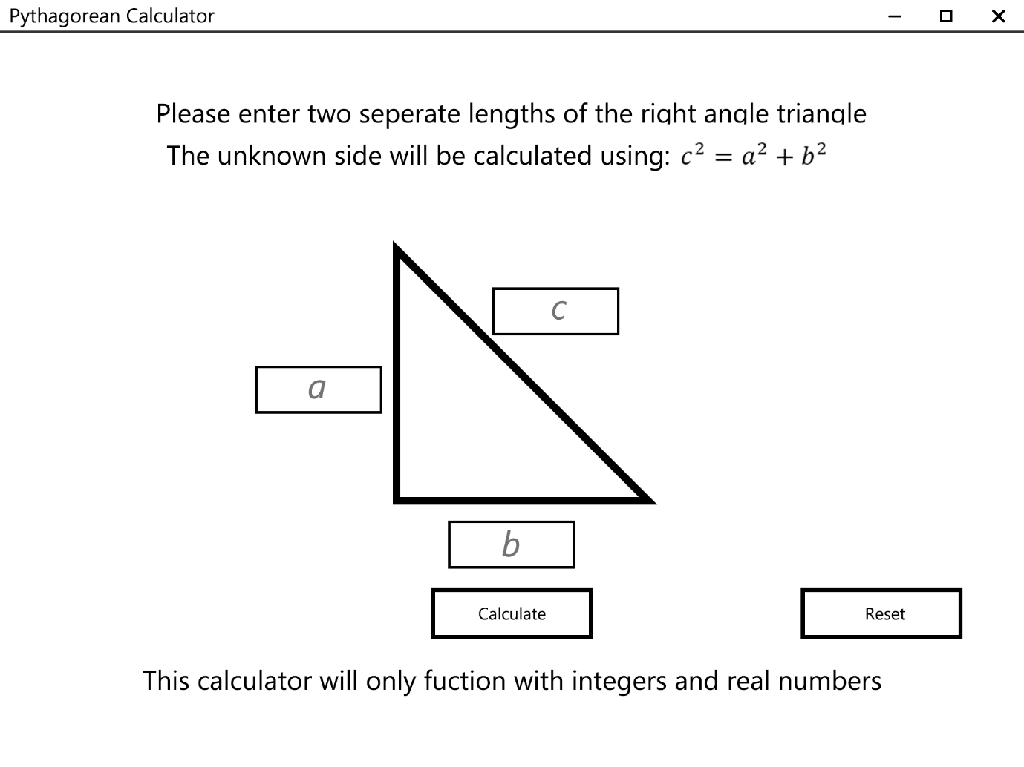The graphical interface of the program should visually resemble something similar seen in the below diagram:

**Function:**

The program would function by the user entering two values into two text fields and leaving the unknown side blank. Once the values are entered the program will check for errors in the input fields and if solvable, will print out the product in the empty field, which can be highlighted and copied to clipboard for use across the computer. A reset button is provided to clear all of the text fields.

**Initially/When model:**

Initially

A = “”

B = “”

C = “”

bool hypotenuse = null

result = “”

When a value is entered into the “a”, “b” or “c” text fields

set “a”, “b” or “c” to the value in the equivalent text fields

When the button “Calculate” is pressed

//Checking for negative numbers

if A or B or C = negative number

Show message box “A triangle cannot have a negative length.”

break (end event)

//Checking for invalid characters (letters, symbols etc)

if A or B or C contain characters

Show message box “Please only enter integers and real numbers.”

break (end event)

//Checking what equation is going to be used

if A and B != “” and C = “”

hypotenuse = true

elseif A and C != “” and B = “”

if C > A

hypotenuse = false

else

Show message box “C must be greater than A.”

break (end event)

elseif B and C != “” and A = “”

if C > B

hypotenuse = false

else

Show message box “C must be greater than B.”

break (end event)

else

Show message box “An invalid amount of values have been entered into the text fields.”

break (end event)

//Running the correct equation

switch hypotenuse

case ‘true’: result = $\sqrt{A^{2}+B^{2}}$

case ‘false’: result = $\sqrt{C^{2}-{(A+B)}^{2}}$

//Extra error detection for redundancy

default: Show message box “An invalid amount of values have been entered into the text fields.”

Display result in empty field

When the button “Reset” is pushed

Clear all text fields

Goto (rerun) initialise

**Notes:**

* When a value is listed as “” it means that the variable is blank or is being wiped
* The formula $\sqrt{C^{2}-{(A+B)}^{2}}$ may seem weird but is designed to take into account the fact that either A or B will be blank (equal to zero) and thus not affect the formula. By doing this, when writing the program, I can avoid writing another case function such as $\sqrt{C^{2}-A^{2}}$ or $\sqrt{C^{2}-B^{2}}$. As long as error detection systems are in place to make sure either A or B is blank, I can save lines of code.